SCHOOL OF COMPUTER SCIENCE AND ARTIFICIAL INTELLIGENCE |  |  |  |  | DEPARTMENT OF COMPUTER SCIENCE ENGINEERING
Program Name: B. Tech |  |  |  | Assignment Type: Lab |  |  | Academic Year:2025-2026
Course Coordinator Name |  |  |  | Venkataramana Veeramsetty
Instructor(s) Name |  |  |  | Dr. V. Venkataramana (Co-ordinator)  Dr. T. Sampath Kumar  Dr. Pramoda Patro  Dr. Brij Kishor Tiwari  Dr.J.Ravichander  Dr. Mohammand Ali Shaik  Dr. Anirodh Kumar  Mr. S.Naresh Kumar  Dr. RAJESH VELPULA  Mr. Kundhan Kumar  Ms. Ch.Rajitha  Mr. M Prakash  Mr. B.Raju  Intern 1 (Dharma teja)  Intern 2 (Sai Prasad)  Intern 3 (Sowmya)  NS_2 ( Mounika)
Course Code |  |  | 24CS002PC215 | Course Title |  | AI Assisted Coding
Year/Sem |  |  | II/I | Regulation |  | R24
Date and Day  of Assignment |  |  | Week5 - Monday | Time(s)
Duration |  |  | 2 Hours | Applicable to  Batches
AssignmentNumber:10.1(Present assignment number)/24(Total number of assignments)
 | Q.No. | Question |  |  |  |  |  | Expected Time  to complete
 | 1 | Lab 10 – Code Review and Quality: Using AI to Improve Code Quality and Readability  Lab Objectives  - Use AI for automated code review and quality enhancement.  - Identify and fix syntax, logical, performance, and security issues in Python code.  - Improve readability and maintainability through structured refactoring and comments.  - Apply prompt engineering for targeted improvements.  - Evaluate AI-generated suggestions against PEP 8 standards and software engineering best practices  Task Description #1 – Syntax and Logic Errors  Task: Use AI to identify and fix syntax and logic errors in a faulty Python script.  Sample Input Code:  # Calculate average score of a student  def calc_average(marks):  total = 0  for m in marks:  total += m  average = total / len(marks)  return avrage # Typo here  marks = [85, 90, 78, 92]  print("Average Score is ", calc_average(marks)  Expected Output:  Corrected and runnable Python code with explanations of the fixes.  PROMPT:CORRECT THE GIVEN CODE  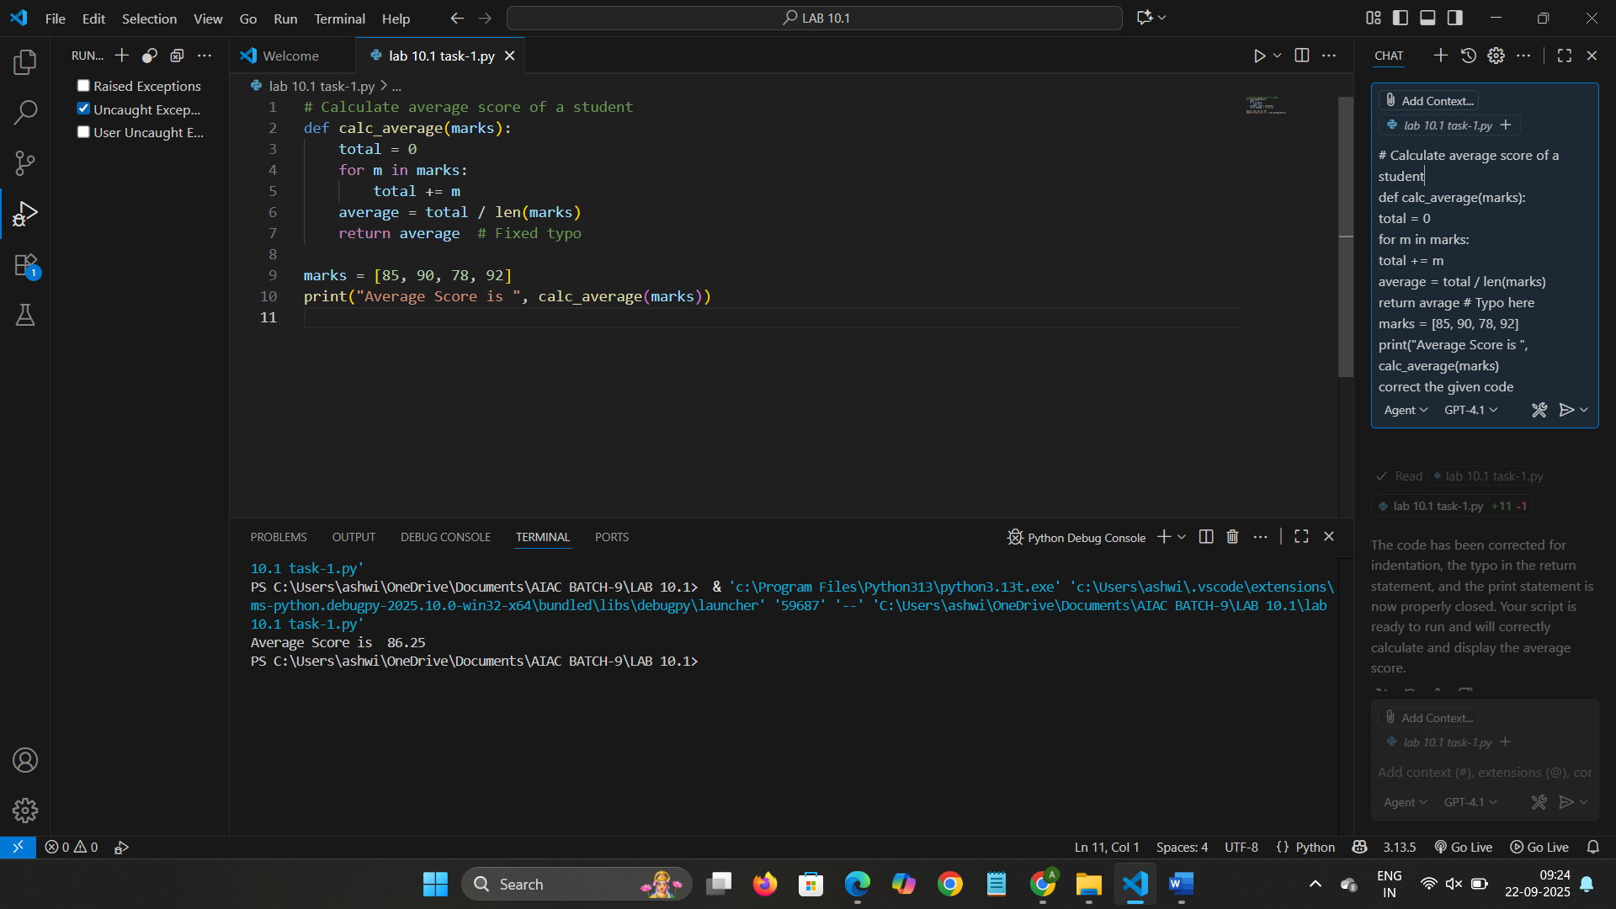  EXPLAINATION:  This code calculates and prints the average score of a student based on a list of marks. The function calc_average takes a list called marks as its parameter. Inside the function, it initializes a variable total to zero, then iterates through each mark in the list, adding each value to total. After the loop, it computes the average by  dividing the total sum by the number of marks, which is obtained using the built-in len() function. The function then returns the calculated average.  Task Description #2 – PEP 8 Compliance  Task: Use AI to refactor Python code to follow PEP 8 style guidelines.  Sample Input Code:  def area_of_rect(L,B):return L*B  print(area_of_rect(10,20))  Expected Output:  Well-formatted PEP 8-compliant Python code.  PROMPT: REFACTOR THE PYHTON CODE USING GOOGLE STYLE DOC STRING  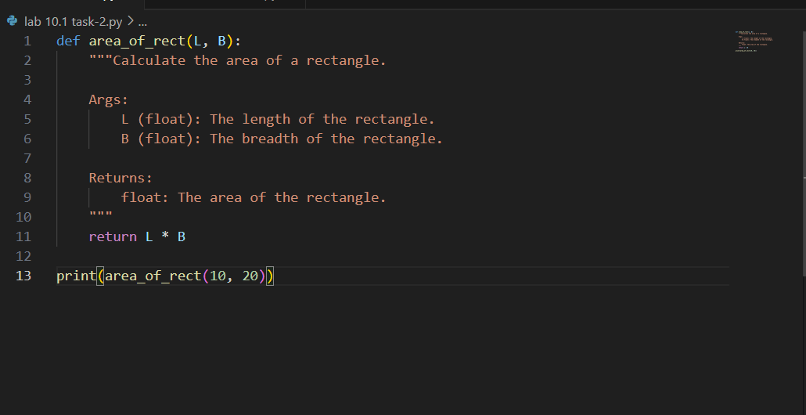  OUTPUT:  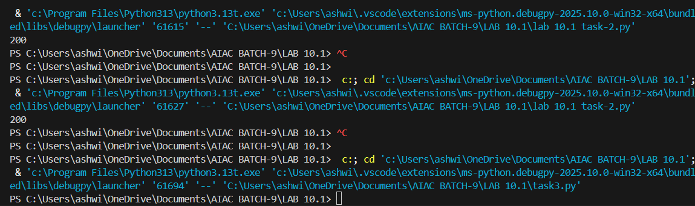  EXPLANATION:  This code defines a Python function named area_of_rect that calculates the area of a rectangle. The function takes two parameters: L, representing the length of the rectangle, and B, representing the breadth (or width). Both parameters are expected to be floating-point numbers, as indicated in the function's docstring.  Inside the function, the area is computed by multiplying the length (L) by the breadth (B). The result of this multiplication is then returned as the output of the function. The docstring provides a clear description of the function's purpose, its arguments, and its return value, which helps other programmers understand how to use the function correctly  Task Description #3 – Readability Enhancement  Task: Use AI to make code more readable without changing its logic.  Sample Input Code:  def c(x,y):  return x*y/100  a=200  b=15  print(c(a,b))  Expected Output:  - Python code with descriptive variable names, inline comments, and clear formatting.  PROMPT:GENERATE CODE WITH DESCRIPTIVE ANALYSIS  INLINE COMMENTS AND OUTPUT  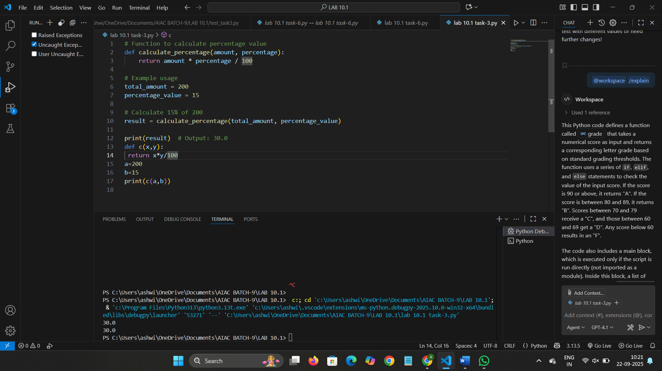  EXPLANATION: The code defines a function named calculate_percentage that takes two arguments: amount and percentage. This function calculates what a given percentage of an amount is by multiplying the amount by the percentage and then dividing by 100. For example, to find 15% of 200, the function multiplies 200 by 15 and divides the result by 100, yielding 30.0.  Task Description #4 – Refactoring for Maintainability  Task: Use AI to break repetitive or long code into reusable functions.  Sample Input Code:  students = ["Alice", "Bob", "Charlie"]  print("Welcome", students[0])  print("Welcome", students[1])  print("Welcome", students[2])  Expected Output:  - Modular code with reusable functions.  PROMPT:GENERATE PYTHON CODE WITH REUSABLE FUNCTION INLINE COMMENTS AND THE OUTPUT  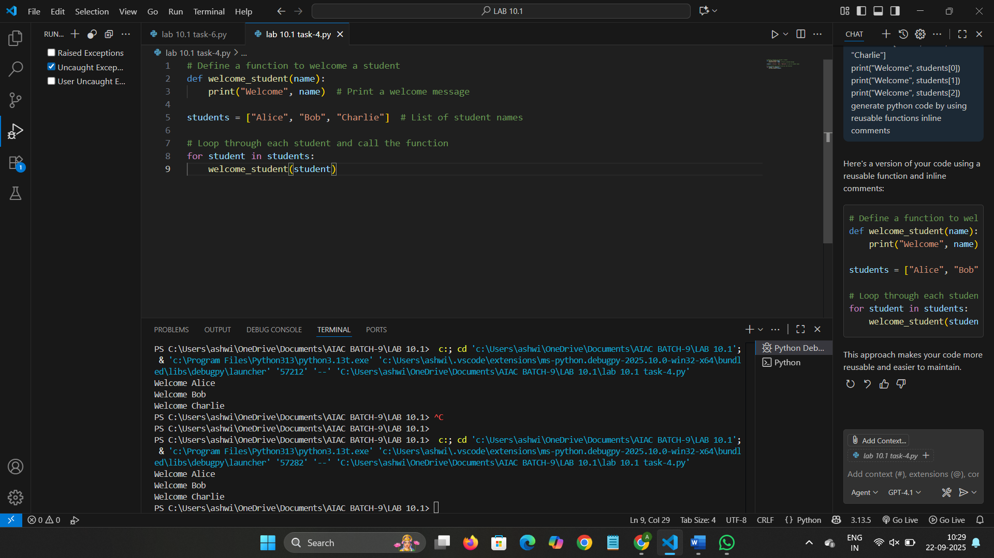  Task Description #5 – Performance Optimization  Task: Use AI to make the code run faster.  Sample Input Code:  # Find squares of numbers  nums = [i for i in range(1,1000000)]  squares = []  for n in nums:  squares.append(n**2)  print(len(squares))  Expected Output:  - Optimized code using list comprehensions or vectorized operations.  PROMPT:REFACTOR THE CODE BELOW WITH LIST COMPRHENSION OF FOR LOOP  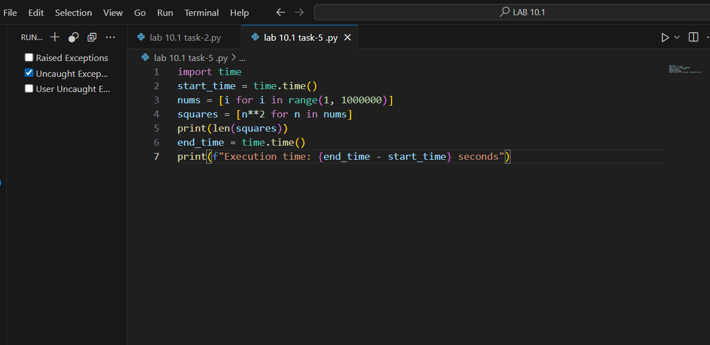OUTPUT:  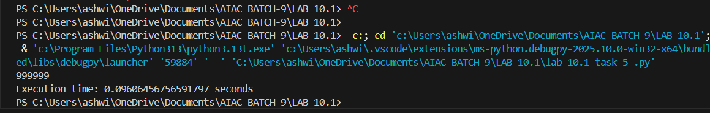EXPLANATION: This code measures how long it takes to create a list of squares for all integers from 1 up to, but not including, 1,000,000. It begins by importing the time module, which provides functions for tracking time. The variable start_time records the current time at the beginning of the program  Task Description #6 – Complexity Reduction  Task: Use AI to simplify overly complex logic.  Sample Input Code:  def grade(score):  if score >= 90:  return "A"  else:  if score >= 80:  return "B"  else:  if score >= 70:  return "C"  else:  if score >= 60:  return "D"  else:  return "F"  Expected Output:  - Cleaner logic using elif or dictionary mapping  PROMPT:CORRECT THE CODE FOR GETTING THE OUPUT  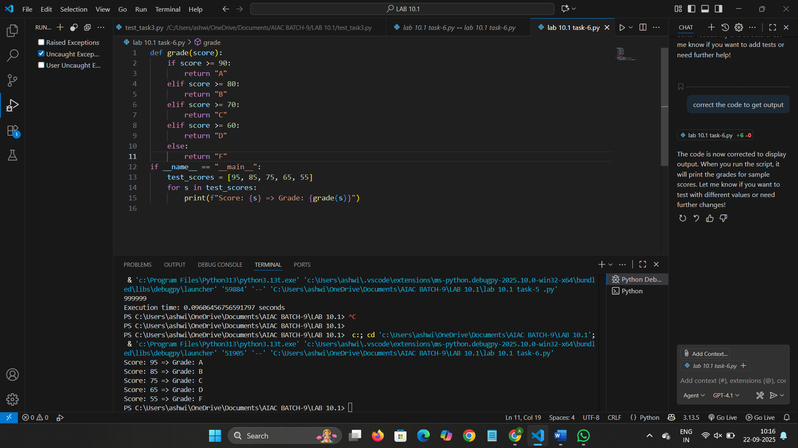  EXPLANATION:  This Python code defines a function called grade that takes a numerical score as input and returns a corresponding letter grade based on standard grading thresholds. The function uses a series of if, elif, and else statements to check the value of the input score. If the score is 90 or above, it returns "A". If the score is between 80 and 89, it returns "B". Scores between 70 and 79 receive a "C", and those between 60 and 69 get a "D". Any score below 60 results in an "F". |  |  |  |  |  | Week5 - Monday

